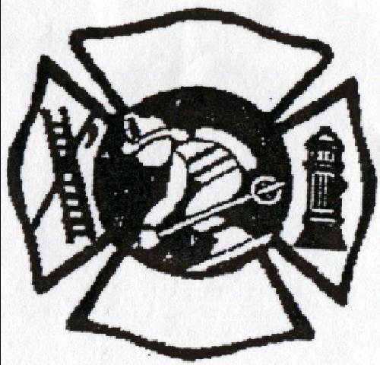
2024 Race at Mountain Creek
Celebrating 34 Years! New Jersey Firefighters Ski Race
Mountain Creek North Ski Area
200 Route 94 - Vernon, NJ 07462

Hosted by
Jersey City Firefighters and Officers

Friday, February 9, 2024
Check-In 8:00am / Race Start 10:00am / Race Finish 12:00pm
Buffet Lunch included 11:30am-1:30pm (Cash Bar) T-Shirt included.
Awards 2:00pm
Racers will need to access Mountain Creek Link to acquire lift tickets.
Pin will be given when the team is registered.
PROCEEDS BENEFIT
THE BURN CENTER AT COOPERMAN BARNABAS

$90 per person/ $450 per team of five

Partial teams are accepted (We combine partial teams or fill in your team)

To keep buffet costs at a minimum. The committee must provide a total head count one week prior to the race Kindly pre-register. This will also make check-in faster and more efficient.

For information call: Mark Ellerson at (609) 709-8174 or e-mail markellerson@aol.com

Team pre-registration of $450 due by February 2, 2024

Checks made payable to: NJFF Ski Race
c/o Mark Ellerson
20 Long Acre Drive
Cream Ridge, NJ 08514
(609) 709-8174
OFFICIAL RULES

- Five-person teams must carry one 50-foot length of hose through gated racecourse.
- All racers must wear fire helmets and turnout coats. Loss of any gear or part of results in 5 second penalty for the team.
- Any team member(s) not holding hose through finish gate will result in 5 second penalty for the team. Any member(s) not finishing the course will result in 5 second penalty for the team.
- Minimum of 3 racers must cross finish line holding the hose to score a time.
- Hoses supplied by Race Committee. Racers supply their own turnout gear and helmets.
- All racers must sign a release on registration form to be eligible to race.
- One race time per registration, unless directed by Race Committee

This form may be duplicate

New Jersey Firefighters
34th Ski Race
Friday, February 9, 2024

Registration $90 per person or $450 per team of five
Please supply a legible email address to receive code for lift Ticket.
Department Name/Town ____________________________________________________________
Team Captain _____________________________________________________________________

Address__________________________________________________________________________

Cell Phone _________________________________Unit# _________________________________

Email ____________________________________________

PRINT NAME SIGNATURE

1. ______________________________ ________________________________

2. ______________________________ ________________________________

3. ______________________________ ________________________________

4. ______________________________ ________________________________

5. ______________________________ ________________________________

In consideration of your accepting this entry, I hereby, for myself, my heirs, executors, and administrators, waive and release any rights and claims for damages I may have against the New Jersey Firefighters Ski Race committee, their spouses, their representatives and successors, and Mountain Creek Ski Area for all injuries suffered by me, or personal damage incurred in connection with said event. I certify that I am physically fit and have sufficiently trained for the completion of this race. I also give permission for the use of my name and/or picture in any newspaper, broadcast, telecast or any other account of this event.

PLEASE ENCLOSE FULL FEE $450 WITH COMPLETED FORM

MAKE CHECKS PAYABLE TO: NJFF SKI RACE

MAIL TO ARRIVE BY: February 2, 2024

Send to: Mark Ellerson
20 Long Acre Drive
Cream Ridge, NJ 08514

THERE WILL BE NO REGISTRATION DAY OF RACE

